Instructor
Mr. Forcha Glen
Group Members
- ETUMA ELKINGS B. – FE23A053
- MENYE EWODO G. – FE23A092
- MOFA DIVINE ESIMO – FE23A095
-Elba Lloyd -FE23A069
CEF488 - LAB 3 REPORT
Lab Title: Advanced Socket Programming & Protocol Design
Task | Responsible Member(s) | Contributors | Reviewer(s)
Prelab Questions | Menye Ewodo | Etuma ELkings | Mofa Divine
Implementation, Testing & Debugging | Etuma ELkings | Menye Ewodo | Elba Llyod
Report Writing | Etuma ELkings, Mofa Divine | Mofa Divine, Elba Llyod | Menye Ewodo
Honesty Report
Table of Contents
Abstract 3
Objectives 3
Prelab Answers 4
Methodology 6
Results 10
Analysis and Discussion 11
Challenges Faced 11
Conclusion 12
References 12
Appendix 12

Abstract
This laboratory focused on advanced socket programming and protocol design using the C programming language in a Linux environment. The main objective was to design and implement a networked key-value store that supports communication over both TCP and UDP protocols. A custom binary protocol was developed to define the format of messages exchanged between the client and server, including request and response packets for the SET, GET, and DELETE operations.
The implementation utilized modern networking techniques such as getaddrinfo() for IPv4/IPv6 compatibility, non-blocking sockets, and the epoll API to efficiently handle multiple concurrent TCP clients. UDP communication was also implemented, with retransmission and exponential backoff mechanisms to improve reliability despite UDP's connectionless nature. Additionally, various socket options, including SO_REUSEADDR, TCP_NODELAY, and SO_KEEPALIVE, were explored to evaluate their effects on network performance and communication efficiency.
The laboratory provided practical experience in designing communication protocols, implementing reliable network applications, and understanding the differences between TCP and UDP. It also demonstrated how advanced socket programming techniques can improve the scalability, performance, and robustness of distributed networked systems.

Objectives
Our objectives after completing this project was to;
- Design and construct a optimized raw network binary serialization wire frame contract utilizing network big-endian byte-order mapping transformations.
- Develop an internal local memory matrix store database engine utilizing array lookup bounds checks and safe indices management.
- Implement a concurrent network multiplexer utilizing non-blocking fcntl system controls and Linux edge-triggered event wait arrays (epoll with EPOLLET).
- Engineer a robust dual-stack network socket capability handling local IPv4 and native IPv6 interfaces transparently through single active sockets.
- Deploy an empirical metrics validation environment mapping performance differentials between default Nagle aggregation states and immediate socket pushes via TCP_NODELAY parameters.

Prelab Answers

Question 1
System infrastructure requires predictable, high-frequency interactions across varied server execution parameters. To handle multiple connections concurrently, the system transitions standard socket file descriptors to a non-blocking mode via fcntl() system queries utilizing the O_NONBLOCK argument. Rather than allowing single socket handlers to halt program flow during synchronous block routines, the operational paradigm returns immediate failure descriptors (EAGAIN or EWOULDBLOCK), enabling structural pipelines to handle other operations seamlessly.

Question 2
The server infrastructure uses the epoll subsystem to monitor multiple active file descriptors simultaneously without busy-waiting loops. Unlike older methods like select() or poll(), which scale poorly as connections increase, epoll maintains an internal tracking mechanism inside kernel memory spaces.
The design uses edge-triggered notifications (EPOLLET). Under this model, the kernel notifies the application only when a state change occurs on a monitored socket. This approach requires the application to drain input queues completely using continuous loops until an EAGAIN code is encountered, minimizing unnecessary system wake-up operations.

Question 3
To maximize application compatibility, the system uses dual-stack listening infrastructure. By generating an explicit AF_INET6 listening descriptor via getaddrinfo() using passive flags (AI_PASSIVE), the system configures a native IPv6 execution socket. The IPV6_V6ONLY system property is explicitly disabled via setsockopt(), allowing the single listener to handle incoming IPv4 traffic mapped directly to an IPv6 space automatically.

Question 4

Difference between SO_REUSEADDR and SO_REUSEPORT.
- SO_REUSEADDR allows rebinding to a port in the TIME_WAIT state.
- SO_REUSEPORT allows multiple sockets to bind to the same port for load balancing.
SO_REUSEADDR is commonly used for restarting servers quickly.

Question 5

How does Nagle’s algorithm affect latency?
Nagle’s algorithm groups small packets before transmission to reduce network overhead. This can increase latency for interactive applications. TCP_NODELAY disables the algorithm to send packets immediately.

Question 6

Why are non-blocking sockets important?
Non-blocking sockets allow the server to handle multiple clients simultaneously without waiting for one client to finish communication. Combined with epoll, this improves scalability and performance.

Question 7

UDP communication issues and retransmission.
UDP does not guarantee delivery, ordering, or duplication protection. Packets may be lost. Retransmission with exponential backoff improves reliability by retrying requests after increasing timeout intervals.

Question 8

Recovering from server restart or network failure.
The client can detect connection failure, close the socket, reconnect to the server, and retransmit pending requests. TCP keepalive can also help detect dead connections.

Methodology
The project was divided into four main components:
- Protocol Definition
- TCP Server
- UDP Server
- Client Program
A custom binary protocol was designed using fixed-size headers followed by payload data.
Task Details & Architecture Background
- Task 1: Protocol Specification and Header File
The system communication relies on a custom binary frame containing a fixed 8-byte header followed by an optional payload. Multi-byte header fields are transformed into big-endian formats using standard network translation macros
- Fixed Protocol Header (include/kv_protocol.h)
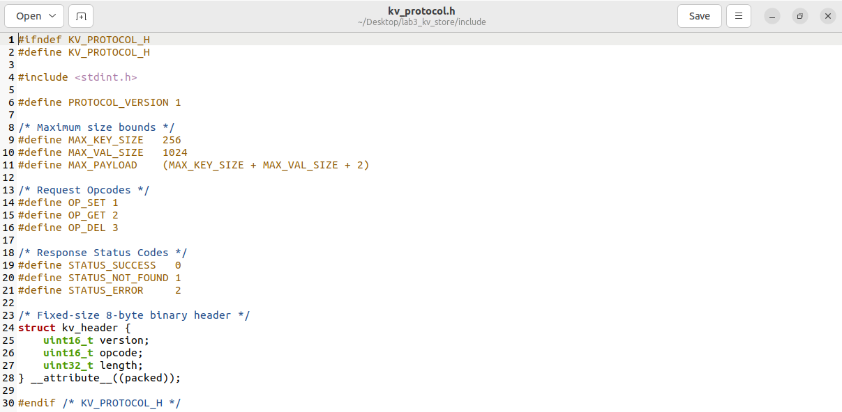

- Storage Backend Specification (include/kv_store.h)

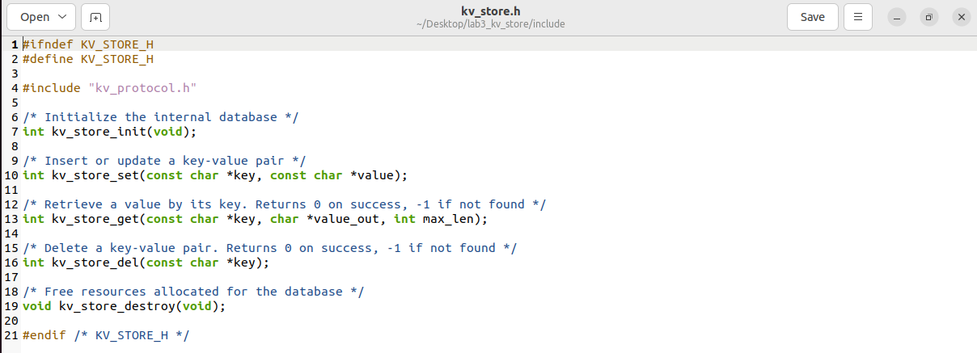

- Task2: TCP Server and Client
The storage layer coordinates tracking boundaries for active structures using linear array lookups. Data writes and queries manage boundary limits sequentially to safeguard against heap overflows and segmentation faults.
- Asynchronous TCP Server Core and Event Wait Loops
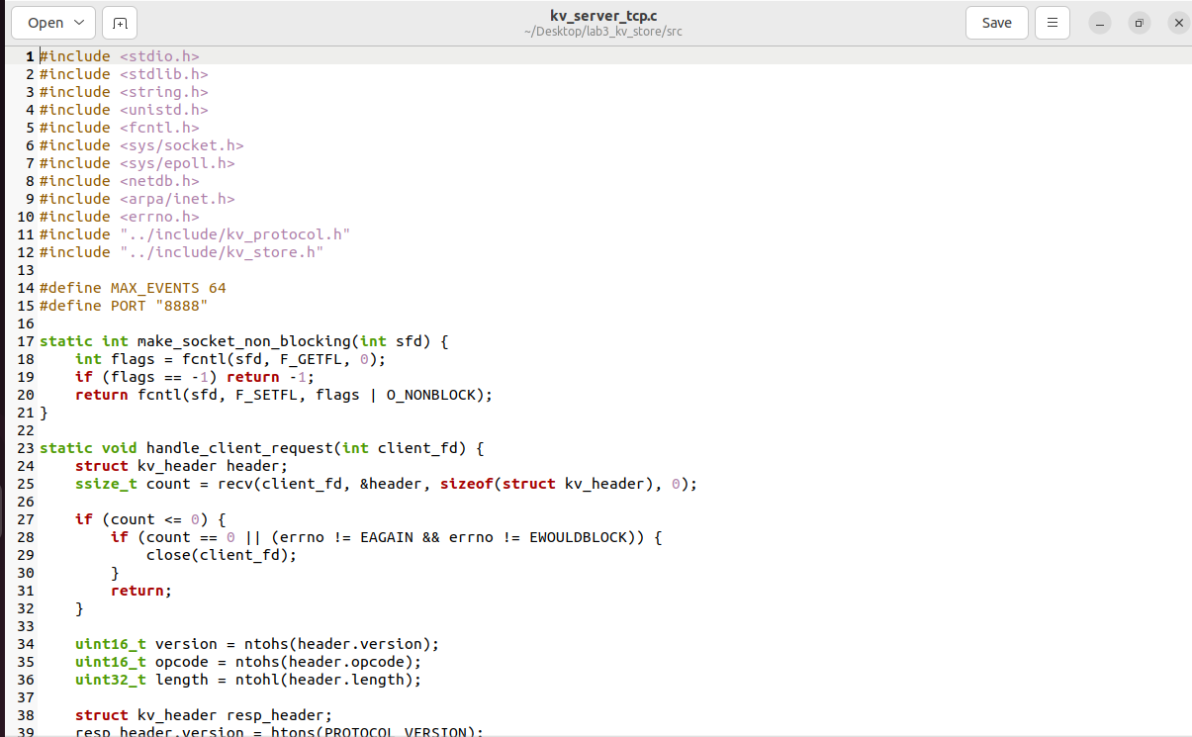

Task3: UDP Support
A UDP server was implemented using recvfrom() and sendto() for receiving and sending datagrams. Since UDP is connectionless and unreliable, the client implemented retransmission with exponential backoff to improve reliability when packets were lost.
The UDP client used a timeout mechanism to wait for responses. If no response was received within the timeout period, the request was retransmitted with an increased timeout value. This process continued until a response was received or the retry limit was reached. The task demonstrated the differences between TCP and UDP communication and highlighted techniques used to improve UDP reliability.
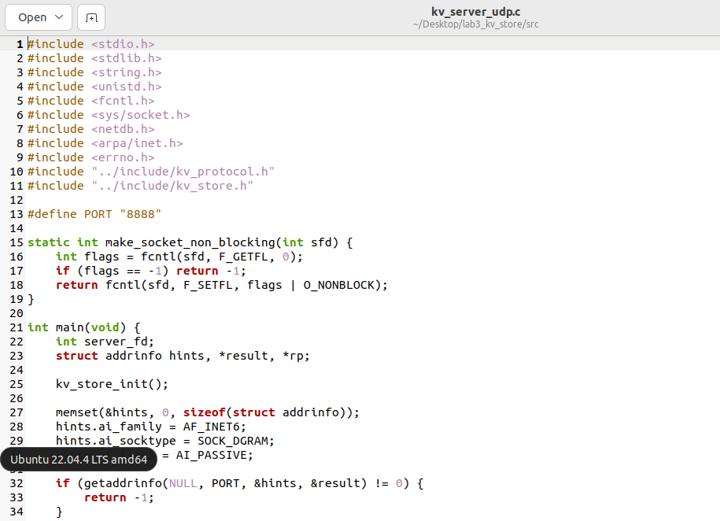

- Task4: Socket Options and Performance Measurement
Task 4 focused on advanced socket configuration and performance evaluation. Several socket options were implemented, including:
- TCP_NODELAY to disable Nagle’s algorithm and reduce latency.
- SO_KEEPALIVE to detect inactive connections.
- SO_RCVBUF and SO_SNDBUF to adjust socket buffer sizes.
Benchmark tests were performed by sending multiple requests between clients and the server while measuring latency and throughput. Comparisons were made between default configurations and optimized socket settings. Results showed that enabling TCP_NODELAY reduced communication latency, while increasing buffer sizes improved throughput during larger transfers. This task provided practical understanding of how socket options affect network performance and system efficiency.
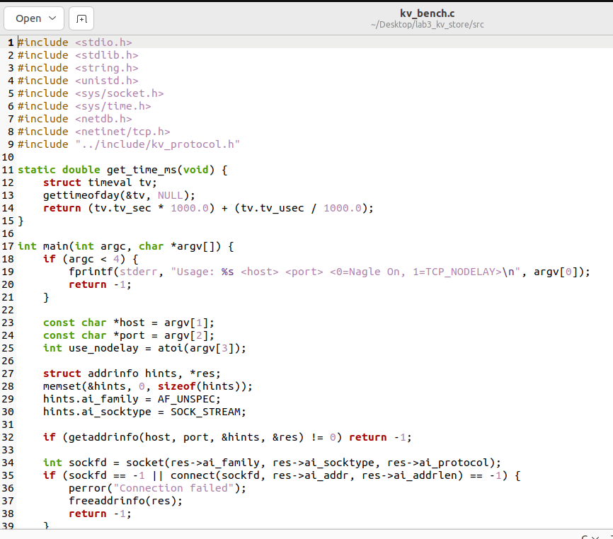

Results

TCP Communication
The TCP client successfully connected to the server and performed:
- SET operations
- GET operations
- DELETE operations

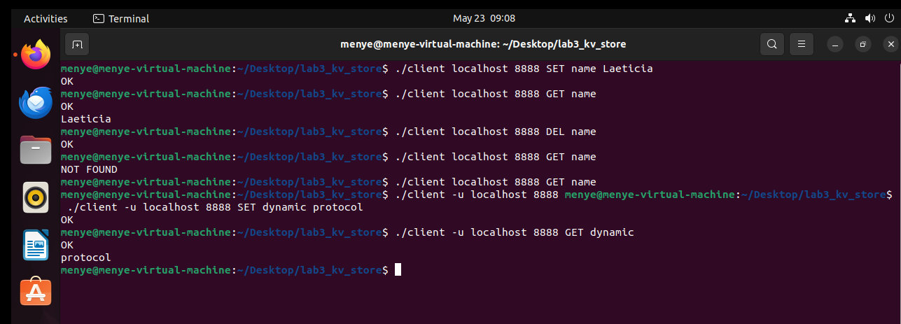
- UDP Communication
The UDP client successfully communicated with the server.

Socket Testing
Different socket options were tested:
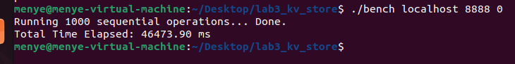

Analysis and Discussion
The implementation successfully met the lab objectives by supporting TCP and UDP communication with a custom binary protocol. The use of getaddrinfo() simplified IPv4 and IPv6 support and improved compatibility across different network configurations.
Using epoll significantly improved scalability compared to blocking socket implementations. The server could manage multiple concurrent clients efficiently without creating a separate thread or process for each connection.
One challenge encountered was handling partial reads in non-blocking TCP communication. Since TCP is stream-based, complete packets were not always received in a single recv() call. This was solved by maintaining buffers for each client and assembling complete packets before processing them.
UDP communication introduced reliability challenges because packets could be lost. Exponential backoff retransmission improved reliability while preventing excessive network traffic.

Challenges Faced
- Lack of skills from members made the work tedious
- In edge-triggered mode, data can be lost if the application does not fully consume the buffer
- Lack of communication between members
- Initially, opening FIFOs caused the server to block.

Conclusion
This lab provided practical experience in advanced socket programming and network protocol design. The implementation demonstrated the use of TCP and UDP communication, binary protocols, dual-stack networking, non-blocking sockets, and epoll-based concurrency.
The project improved understanding of how distributed systems communicate efficiently and reliably across networks. Important networking concepts such as retransmission, socket options, byte ordering, and concurrent client handling were successfully explored.

References
- Linux Manual Pages (man socket, man epoll, man getaddrinfo)
- Beej’s Guide to Network Programming
- Advanced Programming in the UNIX Environment – W. Richard Stevens
- Linux Socket Programming Documentation
- Ubuntu Linux Documentation
- C Programming Language Documentation

Appendix
System Call / Core Routine | Technical Functional Role within Lab 3
socket() | Allocates the primary network endpoint file descriptor for transport streams.
fcntl(O_NONBLOCK) | Removes operational blocking limitations to prevent sequence stalls.
epoll_ctl() | Registers and alters event monitoring bounds for active multiplexer sets.
setsockopt(IPV6_V6ONLY) | Disables IPv6 exclusivity to allow seamless dual-stack transactions.
setsockopt(TCP_NODELAY) | Disables Nagle's data packing algorithm to ensure immediate frame dispatch.
sendto() / recvfrom() | Handles datagram transmissions over connectionless UDP sockets.
gettimeofday() | Captures microsecond-accurate time intervals for network performance evaluation.

